# Quicken Direct Connect

The Direct Connect username and password can be set up by the member in Online Banking (Additional Services tab> Connectivity for Quicken) or by an employee for the member in Admin Platform (Admin tab> Direct Connect). Direct Connect to Quicken allows the member to verify his/herself in Quicken with the Direct Connect password and Syncs account information into his/her Quicken profile automatically (rather than downloading a data file and uploading to Quicken).

**Setting Up Quicken Credentials in Online Banking:**

* Login to Online Banking
* Money Management tab
* Connectivity for Quicken
* Create a password (this does not change the user’s online banking password, it is a password specifically for connecting the user’s Interior FCU account with Quicken).

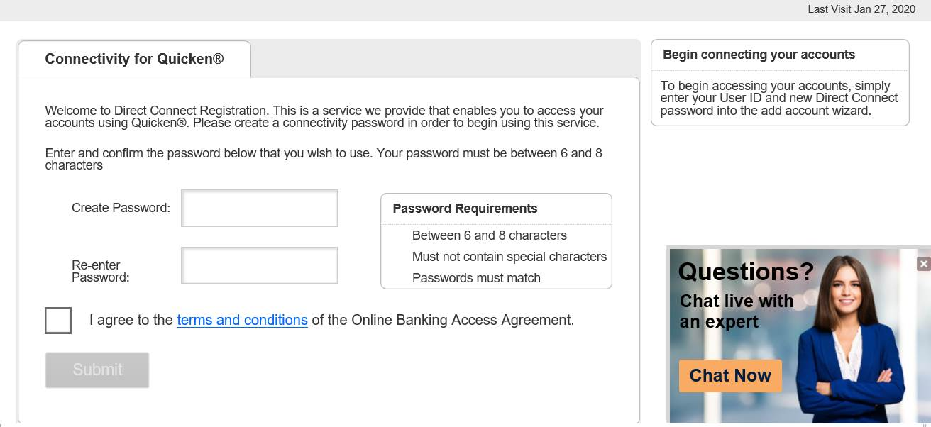

Member logs into Quicken and adds an account:

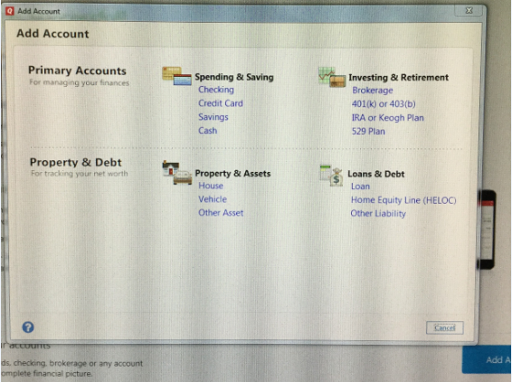

Find Interior Federal Credit Union:

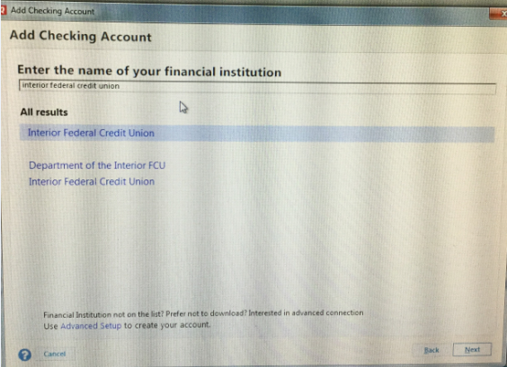

Enter the Direct Connect username and password (which was set up by the member or by an employee for the member:

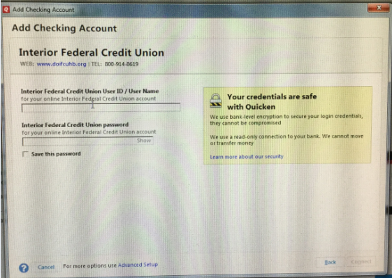

If the correct Direct Connect username and password are entered, the member’s accounts will be found:

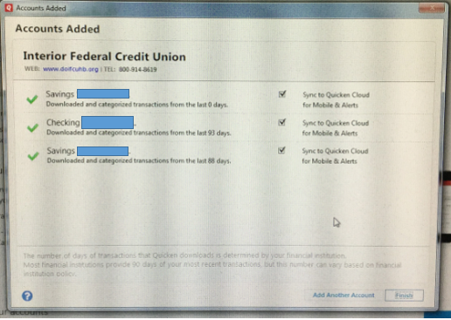

Sync is complete:

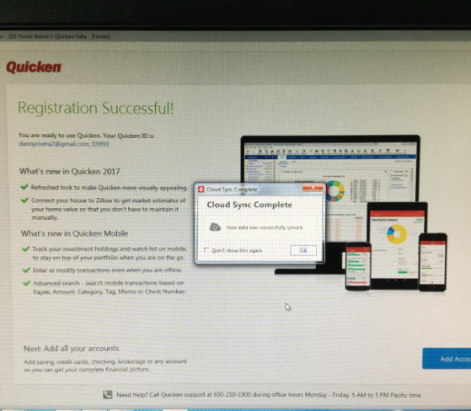

Account information populated on Quicken dashboard:

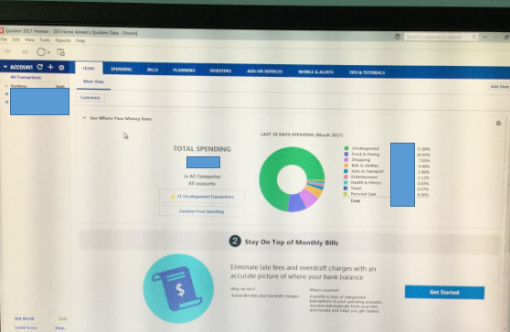

**Quicken in Support Dashboard**

Once a user has registered in Quicken, the user cannot edit the password. If a member needs to be reset: login to Admin Platform> Administration> Direct Connect> lookup the member by account number. You can update the password on behalf of the member, OR you can change the member’s Quicken status to Not Registered. If you change the member to Not Registered, then the next time the member logs into Online Banking he/she can click Connectivity for Quicken again and change the password to whatever they want to (as long as it meets password requirements).

